Some Like it Tepid!
TI-Nspire CX and TI-Innovator Hub with TI-SensorLink™

Project Overview: In this activity, students are challenged to design a system that informs the user if their coffee is too hot to drink. The system should notify the user of three states: Too hot to drink; too cold to drink; and just right to drink. Students may choose to notify the user with a particular color of the Innovator Hub’s onboard LED and/or a particular sound played on the built-in speaker. After designing and building the system, use the hot water and then ice water to test the system. Use the results of your tests to adjust the code to ensure the system works as expected.

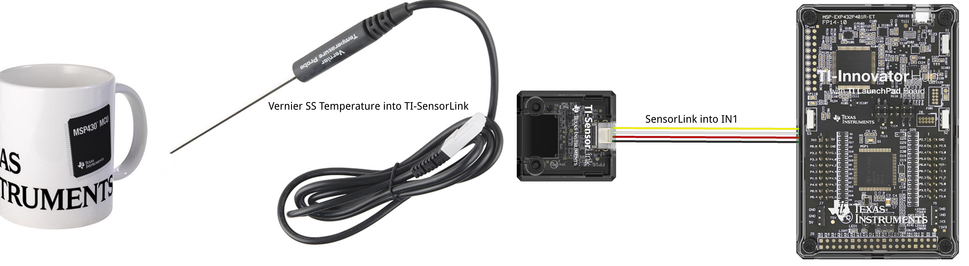
Parts List for project:
- TI-Innovator™ Hub (requires Sketch 1.3 or above)  - TI Nspire CX  - TI-SensorLink™ Adapter  - Vernier BTA SS Temperature Probe | - Coffee cup or styrofoam cup  - Hot water  - Ice in cubes  - Instant coffee (optional)

Example TI-BASIC Code for TI Nspire CX:
- Code snippet to set the RGB color LED to yellow on the Hub:  Send "SET COLOR 255 128 0"  - Code snippet to set speaker to 256 Hz on the Hub for 10 seconds:  Send "SET SOUND 256 TIME 10"  - Code snippet to display a message on the calculator:  DispAt 3,"just right"  - Code snippet to connect and read the temperature sensor:  Send "CONNECT VERNIER 1 TO IN1 AS TEMPERATURE"  Send "READ VERNIER 1"  Get t  DispAt 3,"temperature is",round(t,1), "°C"  Note: ”VERNIER” must be typed into the program using the keypad.  - Code snippet to read and display the temperature sensor continuously every second until the [ecs] key is pressed.  key:= " "  While key≠ "esc"  Key := getKey()  Send "READ VERNIER 1"  Get t  DispAt 3,"temperature is",round(t,1), "°C"  Wait 1  EndWhile  - Complete Program:  Define coffee()=  Send "CONNECT VERNIER 1 TO IN1 AS TEMPERATURE"  key:= " "  While key≠"esc"  Send "READ VERNIER 1"  Get t  DispAt 3,"TEMPERATURE =",round(t,1),"°C"  If t>65 Then  DispAt 4,"too hot"  Send "SET COLOR 255 0 0"  Send "SET SOUND 1024 TIME 10"  Endif  If t≥50 and t≤65 Then  DispAt 4,"just right"  Send "SET COLOR 0 255 0”)  Send "SET SOUND 512 TIME 10"  EndIf  If t<50 Then  DispAt 4,"too cold"  Send "SET COLOR 0 0 255"  Send "SET SOUND 256 TIME 10"  EndIf  Key:= getKey()  Wait 1  EndWhile  Send "SET COLOR 0 0 0"  Send "SET SOUND 0 TIME 10"  EndPrgm | - Code snippet to a make decision tree using the If-Then-EndIf statement:  If t>65 Then  Disp "too hot"  Send “SET COLOR 255 0 0”  Send “SET SOUND 1024 TIME 10”  EndIf  If t≥50 and T≤65 Then  Disp "just right"  Send "SET COLOR 0 255 0"  Send "SET SOUND 512 TIME 10"  EndIf  If t<50 Then  Disp "too cold",  Send "SET COLOR 0 0 255"  Send "SET SOUND 256 TIME 10"  EndIf

