Subject global : Light absorption
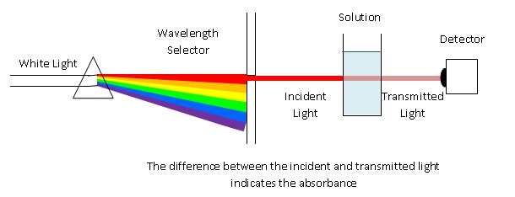
Subject detail : What happens to the intensity of a light source when it travels through a semi-transparent material of increasing width?
Instead of a solution you can also use object glasses with coating and put them together for more absorption.
Requirement : Function, graph and light characteristic
First step : At home : Understanding of the problem : Students must find some situations in relation with our subject.
Second step : In the classroom: Students share their ideas with the other students.
Third step : Students make hypothesis about the phenomena in relation with the observation.
Fourth step : 4 teams. In each team there is 4 students and specific material for the experimentation.
5th step : Observation and treatment of the data : data analysis. Students must choose a math model using regression with the TI83 or TInspire.
Conclusion : Students validate or not the model in relation with the observation.
In case of invalidation they have to find the origin of the problem and try to fix it.
Last step : Presentation of the work to the classroom in 3 slides : Problem-key words-important things. And students ask questions to the group.

